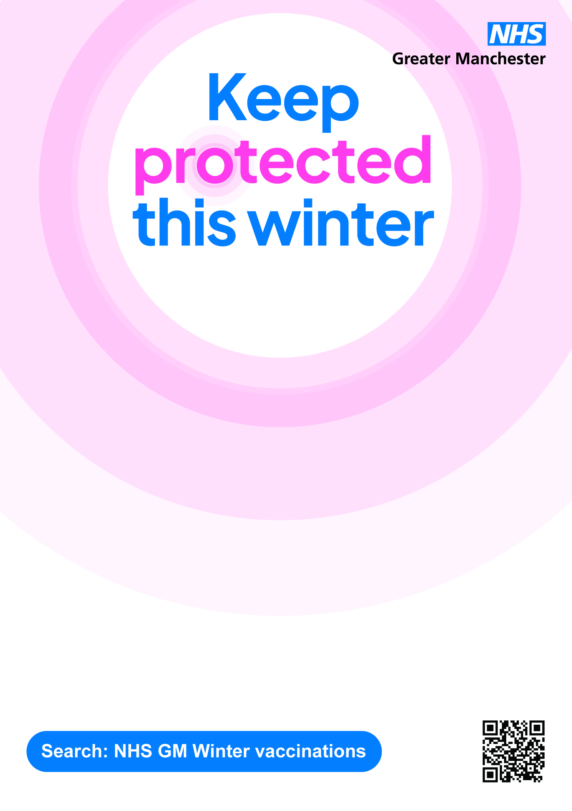

Mobile Outreach Service
Delivering vaccinations across the Wigan Borough
Monday, 24th November 2025
10 am to 4 pm
On the car park at the back of Ince Clinic and Community Centre, Manchester Road, Ince, Wigan WN2 2DJ

